* **@OneToMany & @ManyToOne**

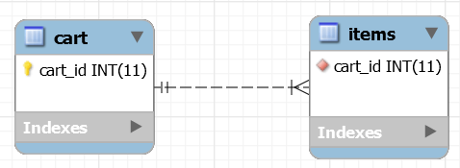 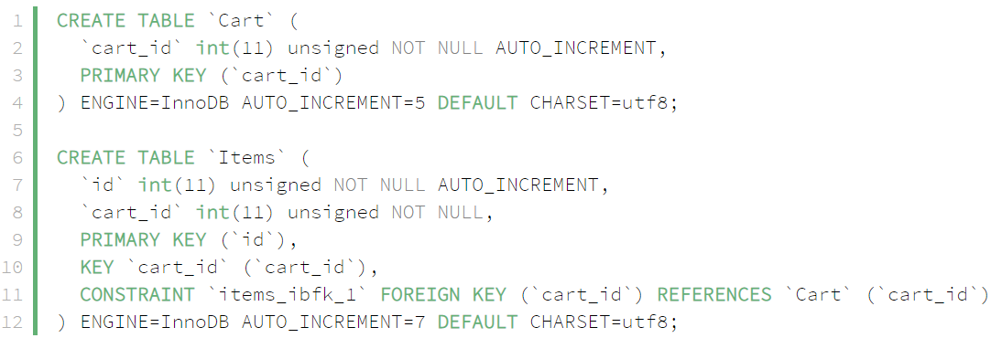

*One cart can have many items*

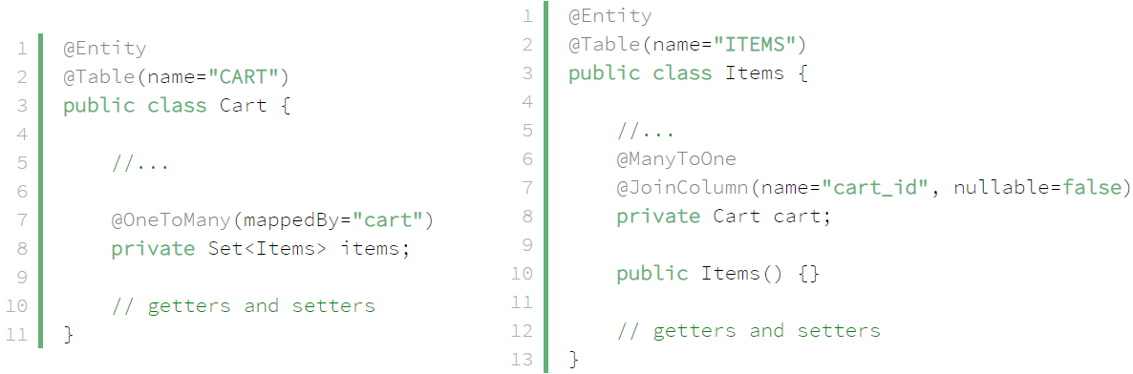

*mappedBy cart which is variable in Java*

* **Best practices**
  + Don’t use unidirectional one-to-many associations
* **Reference**

<https://www.baeldung.com/hibernate-one-to-many>